Trade of Metal Fabrication
Module 5: | Pipe Fabrication
Unit 8: | Pipe Development Three Way Piece
 | Phase 2

Table of Contents
List of Figures 4
List of Tables 4
Document Release History 5
Module 5 – Pipe Fabrication 6
Unit 8 – Pipe Development Three Way Piece 6
Learning Outcome: 6
Key Learning Points: 6
Training Resources: 7
Key Learning Points Code: 7
Orthographic Projection Symbol 8
Third Angle Projection 10
Orthographic Projections of Solids 12
Hexagonal Prism 12
Square Pyramid 12
Cylinder 12
Projections – Truncated Solids 13
A Working Drawing 13
Constructing a Working Drawing 14
Self Assessment 15
Index 16

List of Figures
Figure 1 - Cone Frustum in First Quadrant of Reference Planes 9
Figure 2 - Orthographic View of Cone 9
Figure 3 - Cone Frustum in Third Quadrant of Reference Planes 10
Figure 4 - Third Angle Orthographic View of Cone 10
Figure 5 - Projection Symbols 10
Figure 6 - First Quadrant of Reference Planes 11
Figure 7 - Television in Third Quadrant of Reference Planes 11
Figure 8 - Elevation, Plan and End Elevation 12
Figure 9 - Orthographic Projections of Truncated Solids 13
Figure 10 - Stage 1 15

List of Tables

Document Release History
Date | Version | Comments
13/02/07 | First draft
13/12/13 | SOLAS transfer

Module 5 – Pipe Fabrication

Unit 8 – Pipe Development Three Way Piece
Duration – 7 Hours

Learning Outcome:
By the end of this unit each apprentice will be able to:
- Fabricate a three way equal diameter piece
- Read and interpret pattern development drawings
- Identify and describe semi-automatic vertical and horizontal punching machines
- Calculate using logarithms
- Calculate tensile stress
- Calculate strain

Key Learning Points:
Rk Sk D | Reading, interpretation and drawing of orthographic drawings and pattern development.
M | Use arithmetic and calculate the circumference, pipe lengths and developed pattern lengths. Pitch diameter and hole pitch.  (For more information see Module 5 Unit 1).
Sk D | Draw orthographic projection, develop and transfer pattern developments. Mark flange and pipe for cutting and drilling flame cut, assembly and tack.
Rk | Line of intersections, hole alignment with centre line of development.  (For more information see Module 3 Unit 11).
H | Eye care, hot metals, machine dangers, safety precautions.  (For more information see Module 3 Unit 11 and Module 3 Unit 1).
M Sc | Strength of materials/calculate stress–strain.  (For more information see Module 4 Unit 4).
P | Effective communication, notetaking, safety awareness and quality of work.

Training Resources:
- Fabrication workshop facilities, apprentice toolkit
- Drawing equipment
- Safety clothing and equipment
- Handouts, notes and technical manuals

Key Learning Points Code:
M = Maths D= Drawing RK = Related Knowledge Sc = Science
P = Personal Skills Sk = Skill H = Hazards

Orthographic Projection Symbol
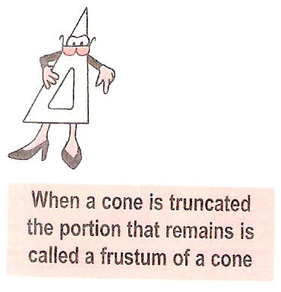
As there are various forms of orthographic projection, it is necessary to place a symbol on each drawing you complete to indicate whether it is drawn using first angle orthographic projection or third angle orthographic projection.
The symbol is the frustum of a cone drawn using the projection system of the entire drawing. Figure 1 shows the frustum of a cone placed in the first quadrant of the planes of reference. The resultant orthographic view of the cone is shown in Figure 2. This orthographic view is further reduced to give the projection symbol shown in Figure 5.
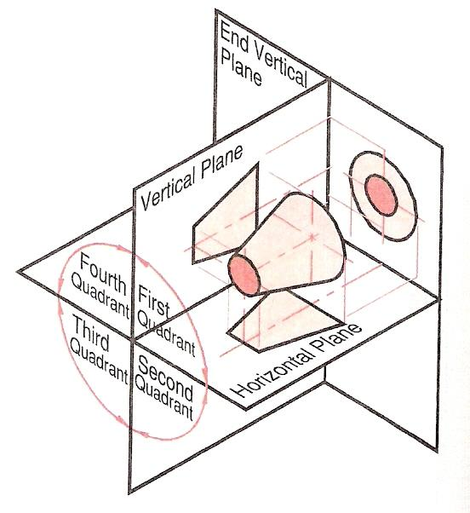
Figure 1 - Cone Frustum in First Quadrant of Reference Planes

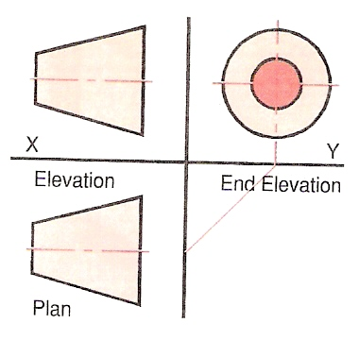
Figure 2 - Orthographic View of Cone
Figure 3 shows the frustum of a cone now in the third quadrant of the reference planes and the resulting third angle orthographic view of the cone is shown in Figure 4. This orthographic view is further reduced to give the projection symbols shown in Figure 5. The projection symbol is added to your drawing alongside the title box.
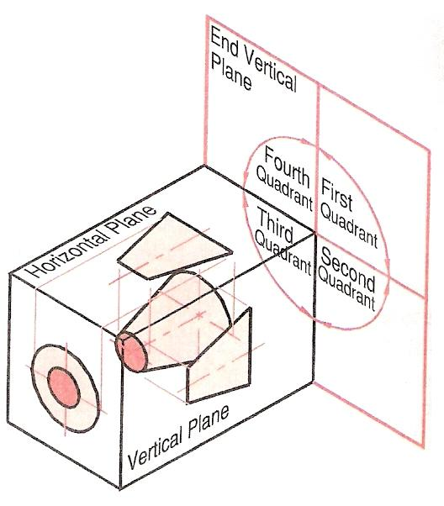
Figure 3 - Cone Frustum in Third Quadrant of Reference Planes

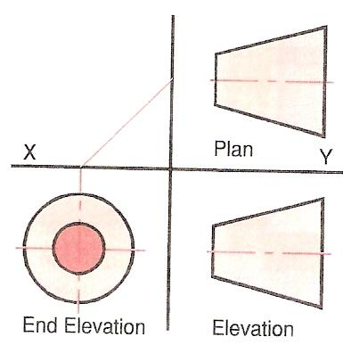
Figure 4 - Third Angle Orthographic View of Cone

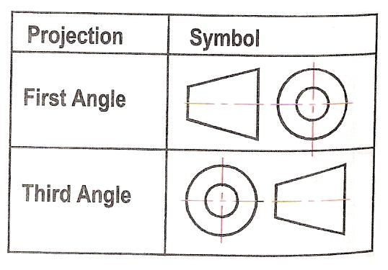
Figure 5 - Projection Symbols

Third Angle Projection
Two forms of orthographic projection are commonly used, these are:
- First angle orthographic projection
- Third angle orthographic projection
Up to now, you have used first angle orthographic projection. In first angle orthographic projection, the object is placed between the observer and the reference planes thus it is placed in the first quadrant of the planes of reference (Figure 6). First angle orthographic projection is the most common form of orthographic projection in European countries.
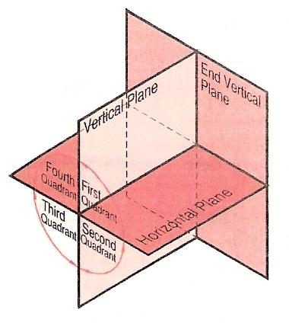
Figure 6 - First Quadrant of Reference Planes
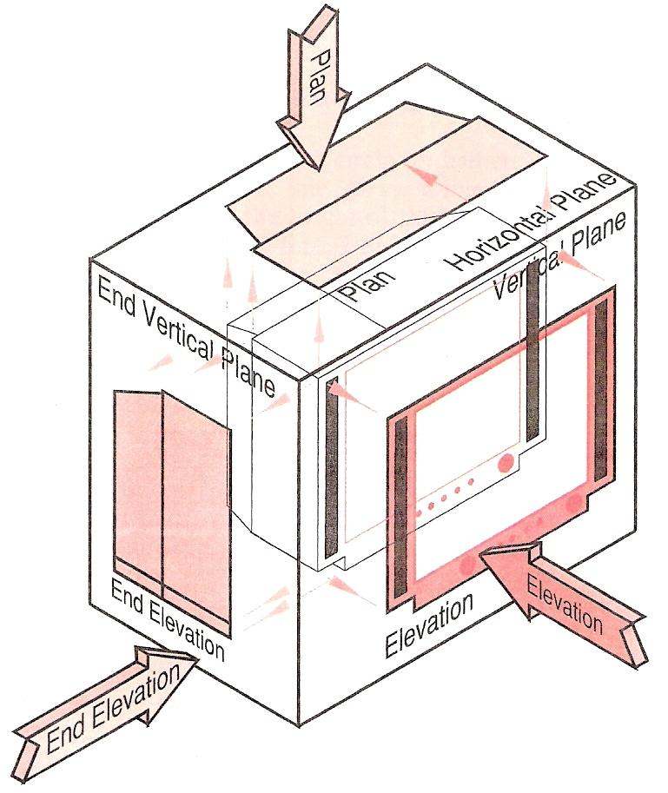
Figure 7 - Television in Third Quadrant of Reference Planes
In third angle orthographic projection, the object is placed in the third quadrant of the planes of reference. Thus, the planes of reference are placed between the observer and the object. Figure 7 shows the television previously drawn in first angle projection now placed in the third quadrant of the planes of reference. The planes unfold to show the elevation, plan and end elevation as shown in Figure 8. This system of projection is most commonly used in the United States. Both methods of projection are equally valid, thus you need to be familiar with both.

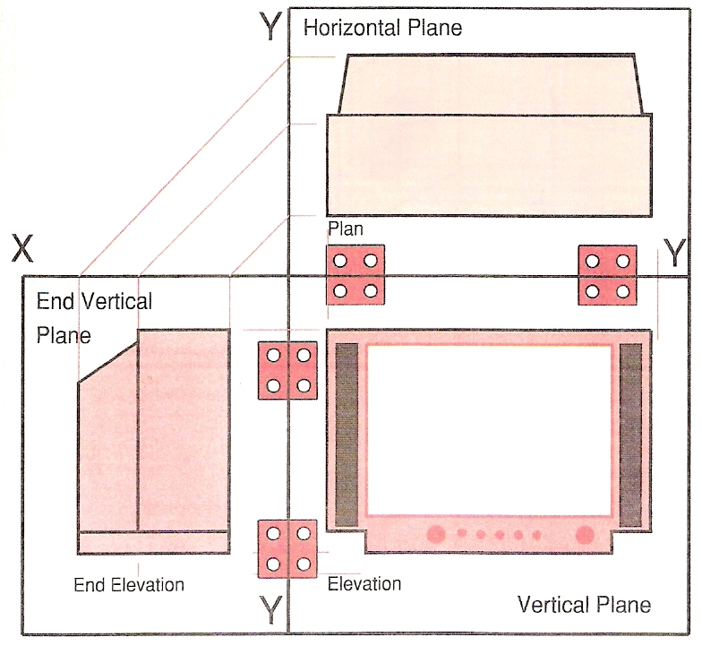
Figure 8 - Elevation, Plan and End Elevation

In third angle orthographic projection, the plan is placed above the elevation. The end elevation is placed on the left side of the elevation when the observer is looking from the left-hand-side of the object, while the end elevation is placed on the right side of the elevation when the observer is looking from the right-hand-side of the object.

Orthographic Projections of Solids

Hexagonal Prism
DRAWINGS 1 and 2 - Figure 9.
- Construct the plan - a regular hexagon of 40 mm side lengths - with the aid of a set square.
- Draw the line XY. Draw a line parallel to the XY line at the height of the solid (70 mm).
- Project vertical lines from the corners of the plan to meet the 70 mm line above XY.

Square Pyramid
DRAWINGS 3 and 4 - Figure 9.
- Draw the plan - a square of sides 40 mm with its diagonals.
- Draw the XY line. Draw a line parallel to the XY line at the height of the solid (65 mm).
- Project a vertical line from the centre of the plan to meet the 65 mm line.
Project vertical lines from the corners of the plan to meet the XY line.

Cylinder
DRAWINGS 5 and 6 - Figure 9.
- Draw the plan - a circle of diameter 60 mm.
- Draw the XY line. Draw a line parallel to the XY line at the height of the solid (60 mm).
- Draw vertical lines from the plan to the height line and complete the projection as shown.
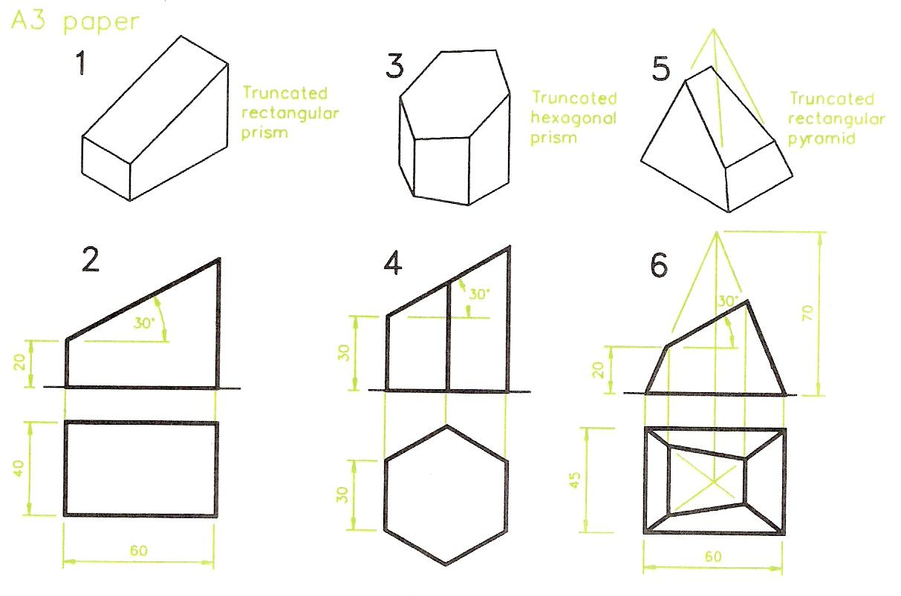
Figure 9 - Orthographic Projections of Truncated Solids

Projections – Truncated Solids
A truncated solid is one which has been cut and had a part removed.

A Working Drawing
Drawings of items in orthographic projection which have been designed for use by those who will actually manufacture the item are often referred to as working drawings. Working drawings usually include:

- One, two or more views in orthographic projection.
- Dimensions of the item, unless the drawing is for assembly purposes, but even then they may require dimensioning in parts.
- A title block in which the following may be printed:
  - A title for the item described in the drawing.
  - The name of the draughtsman or woman.
  - The scale to which the drawing has been made.
  - Other details such as:
    - the date the drawing was completed
    - the materials from which the item is made
    - the initials of the person who checked the drawing for accuracy
    - any possible tolerances to which the item should be machined
    - any finishes which may be required
- The angle of projection - First or Third.
- The dimensioning units.

In the drawings we will be constructing throughout this book, many of the above features may not be included in the drawing. However, your drawings when learning technical drawing should include your name, a title, the scale, the angle of projection and the units of dimensioning.

Constructing a Working Drawing
Stage 1 – Figure 10

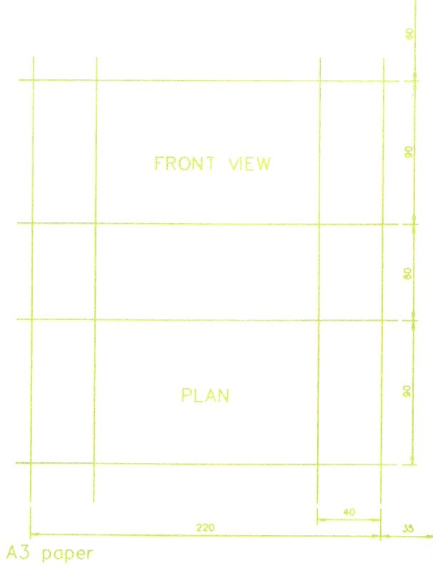
Figure 10 - Stage 1
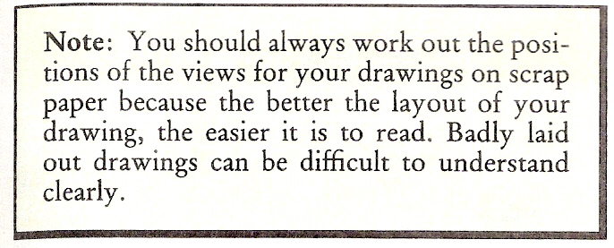

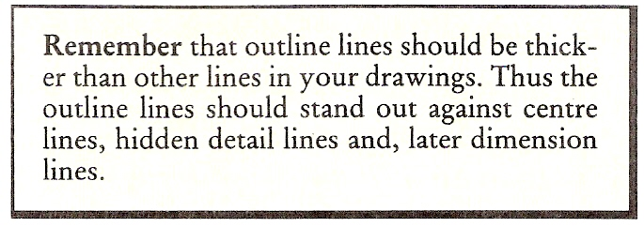

The drawing of a bearing block is to be drawn on an A3 sheet of paper. An A3 sheet is 420 mm by 297 mm. The drawing is to be placed vertically on the paper - in a 'portrait' position. A border line is drawn all around the paper 15 mm in from its edges. This leaves a working area of 390 mm by 267 mm. We shall be drawing a line 20 mm up from the bottom border line to provide space for a title block - this leaves a working area of 370 mm by 267 mm.
Taking dimensions vertically:
- The height of the Front view is 90 mm.
- The height of the plan is 90 mm.
- These two heights leave a vertical space of
370 - 180 = 190 mm.
which allows us to position the top of the Front view 60 mm down from the top border line and allows a space of 60 mm between the two views.
- To position the views in the width of the paper
267 - 220 = 47.
If the right hand space is made 35 mm, this leaves room to place the dimensions on the right hand side of the views
- Figure 10 shows the construction lines based on the above arithmetic.

Self Assessment
Questions on Background Notes – Module 5.Unit 8

No Suggested Questions and Answers.

Index

A
A Working Drawing, 14
C
Constructing a Working Drawing, 15
O
Orthographic Projection Symbol, 9
Orthographic Projections of Solids, 13
Cylinder, 13
Hexagonal Prism, 13
Square Pyramid, 13
P
Projections – Truncated Solids, 14
S
Self Assessment, 16
T
Third Angle Projection, 11

